SBQG BOXED IN BLOCKS for UKRAINE
Thank you for working on the SBQG Boxed In Block project for Ukraine. These instructions will make two (2) Blocked In Blocks that finish at 8-1/2” (or 9” including seam allowances).
You will need two (2) 10” squares (or scraps cut to match the cutting dimensions below), one sunflower fabric and one neutral fabric.
- Cut the 10” squares into 5 pieces, as follows:
First cut the 10” square in half (you will have 2 strips at 5” x 10”). Cut one of the 5”x10” strips in half vertically to yield have 2 strips at 2-1/2” x 10”. Cut the other 5”x10” strip in half horizon- horizontally to yield two (2) 5” squares, then cut one of the squares in half to yyield squares in squares in half to yield two (2) 2-1/2”x5” strips.
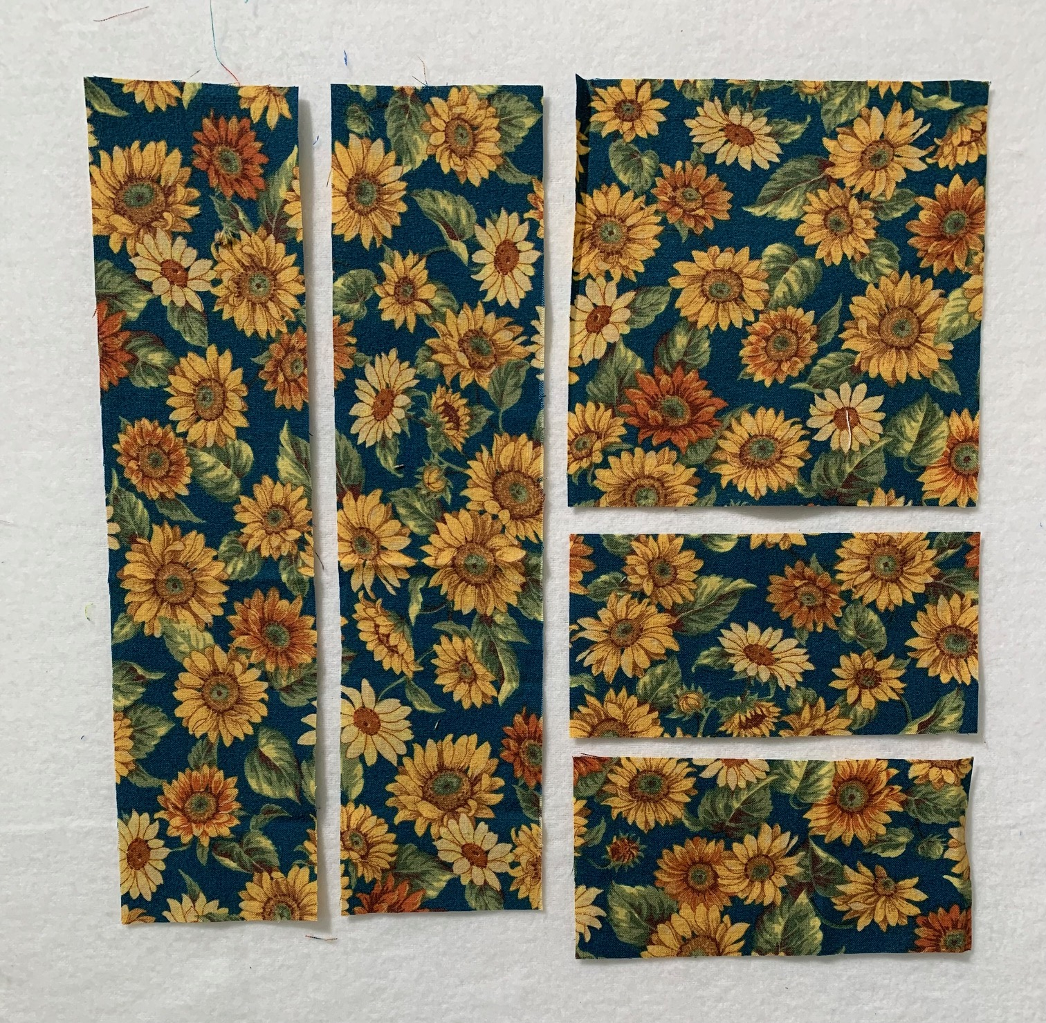

Repeat for second 10” square.

2. Make the Boxed In Unit.

Lay out the pieces for both blocks, switching the center square between them. Sew the 2-1/2” x 5” rectangles to the center squares, press and then add the 2-1/2” x 10” rectangles. Press seams out.
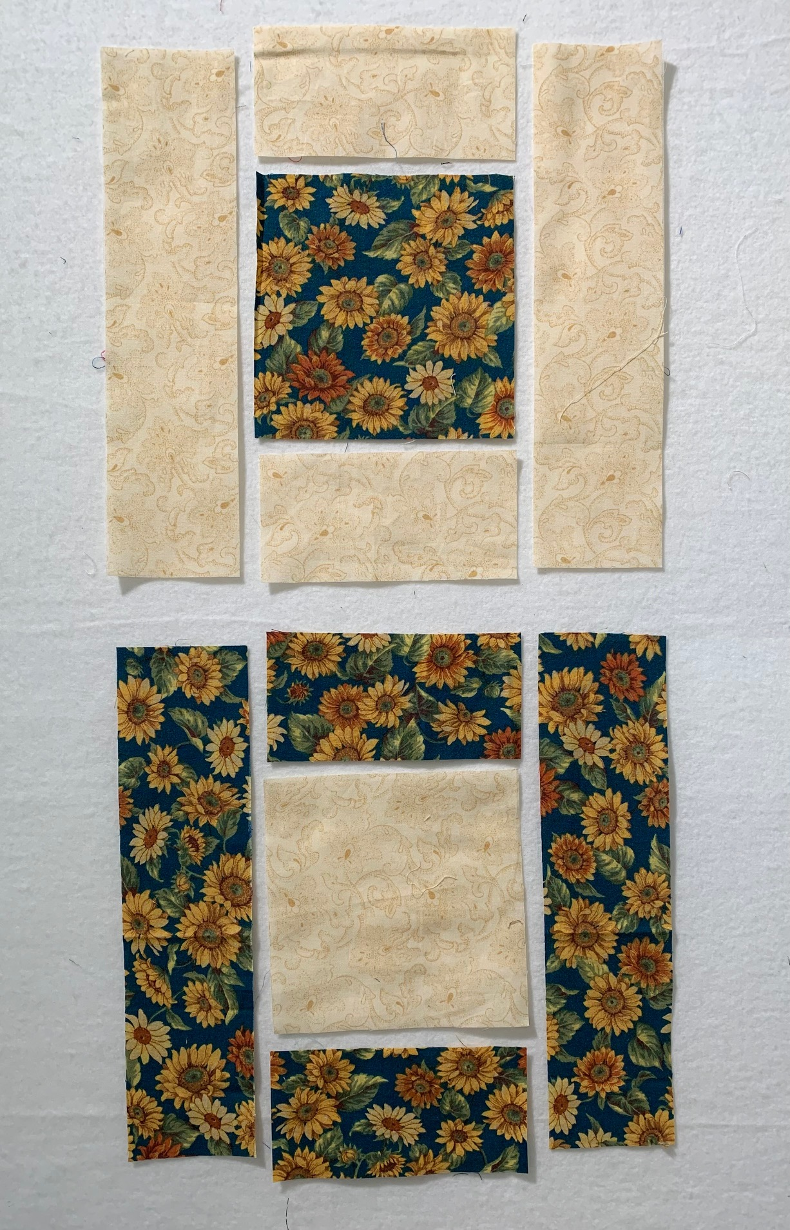

Trim the tails and square the blocks to 9”. If your blocks are a bit small or you would prefer not to square them, that’s perfectly fine. The blocks will be checked before quilts are assembled.

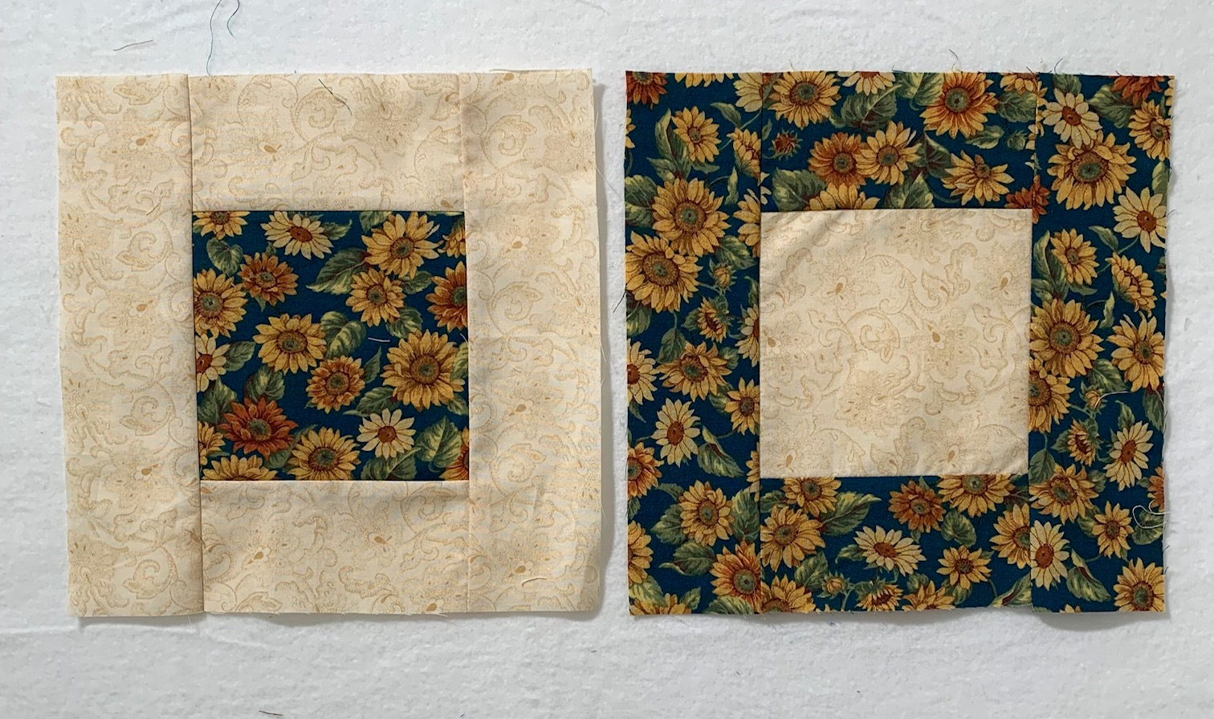
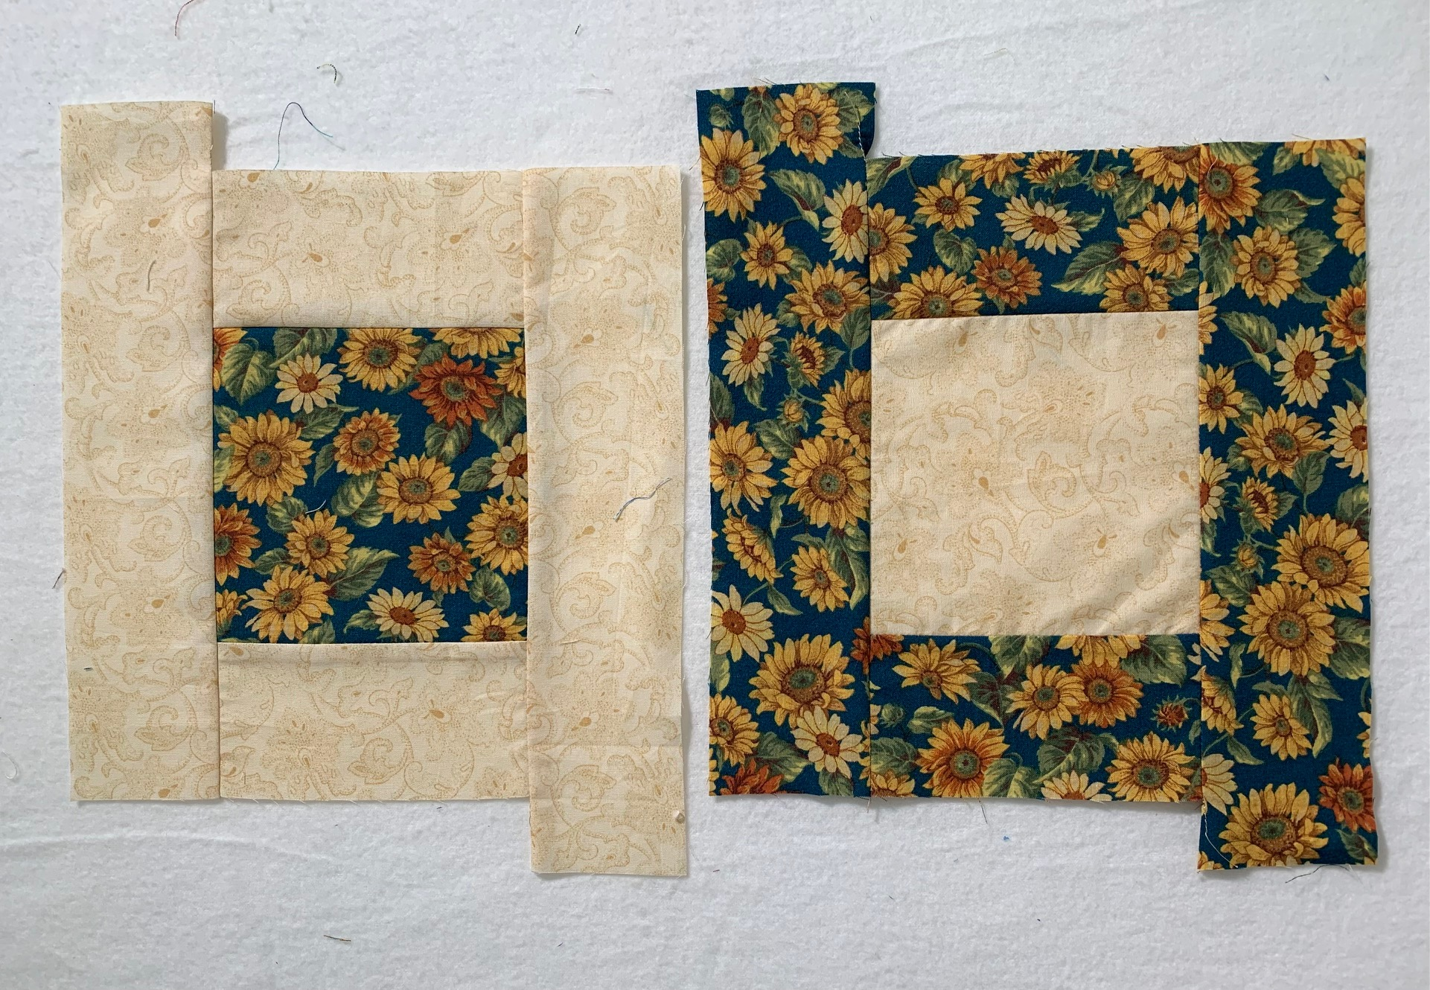

Congratulations on making these two blocks! Now please feel free to make more for more beautiful quilts for Ukraine. Any questions, call/text Nadine Kirk.

Note: Pattern is Free from Cotton Candy Fabrics. 2023

