PERKIOMEN VALLEY BLOCKS FOR UKRAINE
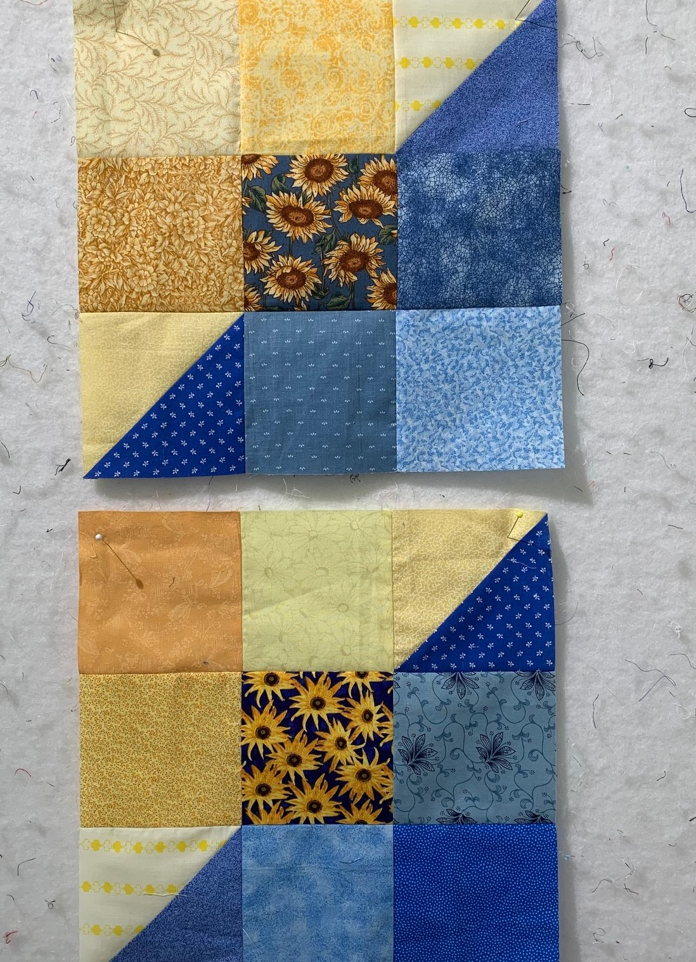
For 2 blocks: 6 – 4-1/2” blue squares
2 – 4-1/2” sunflower print square
6 -- 4-1/2” yellow/gold squares
2 – 5” blue squares
2 – 5” yellow squares
Use the 5” squares to make 4 half square triangles (2 different HST for each block). Set the sunflower square in the center of the blocks. Do not repeat any fabric in the blocks. Block size: 12-1/2”

Return completed blocks to Nadine Kirk (any questions call/text 310/730-3402, call 310/328-6552 or email Nadinekirk@socal.rr.com).

